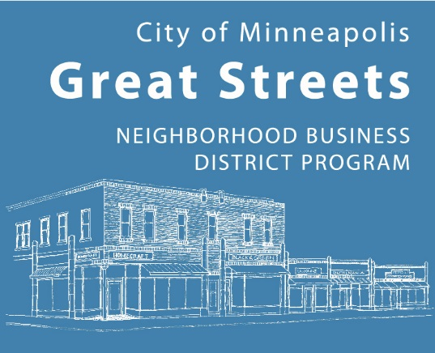

Date posted: October 28, 2026

Proposals due: December 11, 2026

Business District Support (BDS)

Including 38th Street THRIVE Funding
Notice of Funding Availability (NOFA)
Proposal Form

Introduction
Your proposal will not be reviewed if any questions on this form are left blank or if the required Budget form is not emailed as explained in the Submittal Process below.
Parts of the proposal, as well as clarifications made by the chosen applicant, may become part of the final contract with the City. The City has the right to reject any proposal, or to ask for changes so the final scope of activities may be larger or smaller than what was first proposed.

Submittal Process
Send your proposal by email to Judy Moses (judy.moses@minneapolismn.gov) no later than Friday, December 11, 2026, at 4:00 p.m. Include these attachments:
- A completed Proposal Form (required)
- A completed Budget (required; use the provided Excel template)
- Letters of support in a single PDF document (optional)
You will get a confirmation email within 24 hours (or by 4:30 p.m. on December 11, 2026) letting you know the proposal was received.

Application Information

Organization Information:
Name:
Federal ID number: (9-digit #)
Mailing address:
Contact Information:
Name:
Title:
Phone number:
E-mail address:

Total amount requested

Great Streets BDS funding:
38th Street THRIVE funding:
- $50,000 maximum total amount

List the eligible area(s) the proposal would serve:

Activities must be located within a designated area to receive points. Cultural Districts receive 10 points, Priority Eligible Areas receive 5 points, and Eligible Areas receive 0 points.

Need, Outcomes, & Impact (15 pts max)

If you are suggesting more than one activity, number them. Use the same numbers when you answer all the questions.
1. Describe the activities you are suggesting. For each activity, explain:
- What it is
- Why it is needed for your business district
- The results you expect
- How it will help promote, advertise, improve, or grow the success of the businesses and the community
Example response format
Activity ___
- Activity Description:
- Why It’s Needed:
- Expected Results:
- How It Helps the Economy:

2. Explain how your activities will reduce economic gaps in your community.
- Will your activities protect racial diversity? If so, how?
- Will they celebrate and uplift the culture and identity of your district? If so, how?

3. What proof will you send the City to show you met your goals?
(Examples of deliverables you can email as documentation of meeting your goals are listed at the end of this document.)

Organizational Capacity & Partnerships (10 pts max)
Note: The City will also look at how your group or consultants have done on past contracts.
4. Who will carry out these activities?
- Are they staff, volunteers, or consultants?
- Share a short description of their experience doing similar work.
- If you don’t have a consultant yet, explain how you will choose one.

5. Explain your partnerships with other community or cultural groups.
- If you are doing these activities with another group, explain how you will work together.
- How do these partnerships make your business district stronger?
- Please include letters of support. Send all letters together in one attachment with your application.

6. What does your group need to do before starting these activities?
- If you are proposing public art or activities in the City’s right of way, explain how you will get the needed permits or approvals.

7. How were local businesses involved in creating this proposal?
- How will they continue to be involved once the activities begin?

8. Share a list of your Board of Directors and where they work or are connected.

Budget & Leverage (5 pts max)
9. Are these activities one-time costs? Yes or No
The program does not pay for the same thing every year. It is meant to fund activities that respond to changing needs, the economy, and the character of each district.
- If no, how will you fund them in the future? (For example: more membership dues, charging for events, fundraising, or new revenue activities.)

10. Share any extra details about your budget.
- If you listed artists in Question #4, explain how you decided their pay rates.

11. Describe your organization’s current contracts with the City of Minneapolis. Include any additional details about your budget.
- Does your organization currently have any open contracts with the City?
- Which City department is the contract with, and what activities does it fund?
- What is the total contract amount, how much has been spent to date, and what are the start and end dates of the contract?

Authorization

Complete both sections

Submittal Authorization

, on behalf of , hereby authorizes the submittal of this Online Proposal Submittal Form in response to the Business District Support Program, NOFA.

Name:
Title:
Name:
Title:

Consent for Release of Response Data

, on behalf of , hereby consents to the release of its proposal in response to the Business District Support Program, NOFA and waives any claims it may have under Minnesota Statutes Section 13.08 against the City of Minneapolis for making such information public. The foregoing consent and waiver does not extend to financial statements submitted under separate confidential cover, which material will be treated consistently with Minnesota Statutes Section 13.08

Name:
Title:
Name:
Title:

Examples of deliverables:

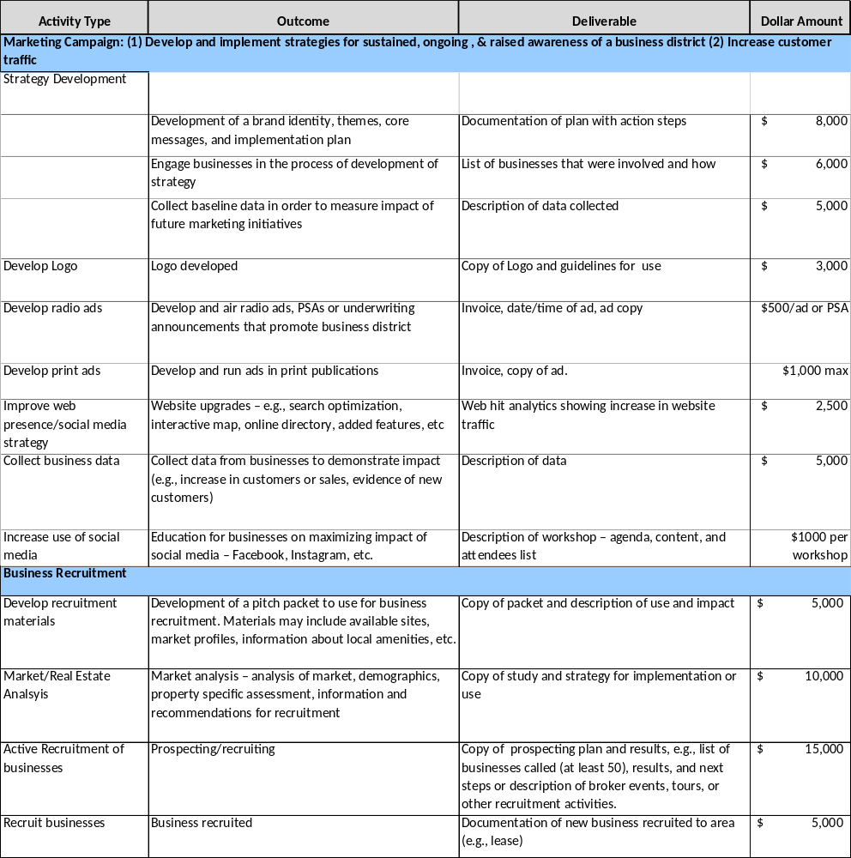

If a partnership or team is proposing, an authorized signature is required from each entity.
If a partnership or team is proposing, an authorized signature is required from each entity.

